Tyler Degen

Linguistics 5801

Problem Set 5

1.)

P(SKF) =

|  |  |
| --- | --- |
| Student Knows Fact | Student Doesn’t Know Fact |
| .4 | .6 |

|  |  |  |
| --- | --- | --- |
| **P(SRH | SKF)** | Raises Hand | Lowers Hand |
| Knows Fact | .8 | .2 |
| Doesn’t Know Fact | .05 | .95 |

|  |  |  |
| --- | --- | --- |
| **P(SCA | SRH)** | Correct | Incorrect |
| Raise | .75 | .25 |
| Lower | .1 | .9 |

2.)

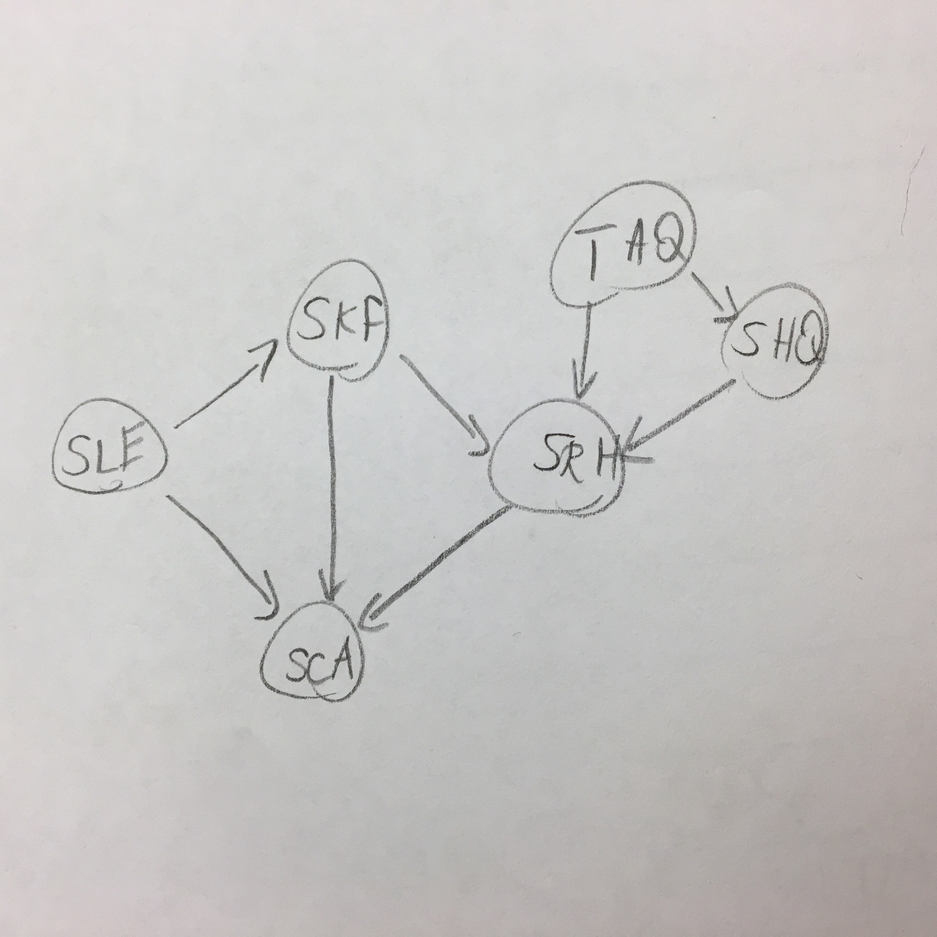

For Student Listening Explaining (SLE), it would add a dependency to the Student Knowing Fact (SKF) and STudent Correctly Answering (SCA) because the additional explanation would both increase students knowing the facts as well as students being able to correctly answer the question should they be called on.

For Teacher Asking Question (TAQ), it would add a dependency to the Student Raising Hand (SRH) and Student Hearing Question (SHQ), because the student would raise their hand in response to hearing the question and the student would not be able to hear the question if the teacher did not ask.

For Student Hearing Question, it would add a dependency to the Student Raising Hand (SRH), because the student would be more likely to raise their hand if they hear the question and less likely if they didn’t.